A000-Eur-Greece-Tiryns-Gold Signet Ring Celebrating the Ergot Ritual of Entheogenesis-15th cent. BCE

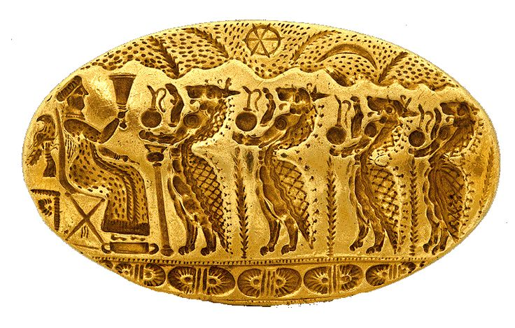

Fig. 1. Gold Signet Ring Celebrating the Ergot Ritual of Entheogenesis, found in Tiryns, Mycenae, 15th cent. BCE. It was probably executed by an expert Minoan goldsmith who was acquainted with New Kingdom Egyptian symbolism.

**Case no.: 4**

**Accession Number:**

**Formal Label:**

**Display Description:**

**LC Classification:**

**Date or Time Horizon:**

**Geographical Area:**

**Map, GPS coordinates:**

**Cultural Affiliation:**

**Media:** **Dimensions:**

**Weight:**

**Condition:**

**Provenance:**

**Discussion:**

**References:**

This Mycenaean ring depicts a procession of four lionesses wearing reptilian capes and holding libation ewers with wheat stalks below the jugs suggesting the presence of the parasitic fungal hallucinogen *Claviceps purpurea* ("rye ergot fungus") on wheat or rye. Above this scene is a ridge of hills with symbols of the Sun and the crescent Moon separated by two wheat stalks (perhaps suggesting the 24 hour duration of the ergot‘s taking effect) and another two wheat stalks are depicted on the opposite side of the heavens. *Claviceps purpurea* is a fungus that produces alkaloids with its fruiting structure (called *Ergot sclerotium*) that induces entheovisions or visions of a divine world, which is what is depicted above these Cretan hills. Below the scene are the cyclopaean walls of Homer’s “mighty Tiryns” that Heinrich Schliemann excavated in 1883-1884.

The goddess holds a rhyton or drinking vessel in her right hand. She is seated on a collapsible throne with a curved back rest. Her feet rest upon a footstool placing her above the approaching lioness-reptiles. The reptile theme suggest that the ergot experience induces a reptilian or antediluvian sense of being extracted from one’s being and put into a watery world where one is swimming through a fluid. Ergot is a fungus that infects cereal grains, replacing kernels of the fruit with small black masses of mycelium. It produces ergotamine, a potent vasoconstrictor and precursor to LSD. Ergot poisoning (St Anthony's Fire) causes hallucinations, outbreaks of the use of which plagued medieval Europe (especially the Dominican-inspired Inquisition of the 12th to the mid-15th centuries AD/CE) and America in 1692 at Salem, MA, and were associated with unexplained itching, constrictions (mimicking being taken by a crocodile or alligator) and bodily eruptions that were taken to be marks of the devil, hence witchcraft.

Behind the Goddess is a falcon tied to a perch suggesting that the Egyptian connotation of Horus as the ruler’s protector is omnipresent. Below the falcon and behind the goddess’s throne are three stalks of pure ergot.

 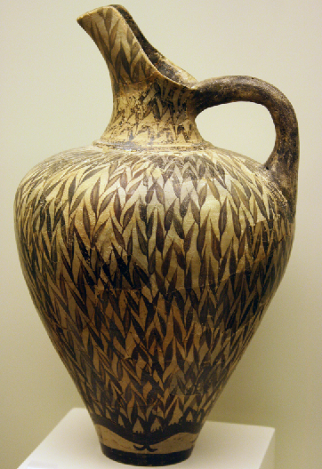

**Left: Fig.** *Claviceps purpura* on wheat stalk from http://www.lycaeum.org/nepenthes/Plants/Claviceps/purpurea.html

**Left Center: Fig.**  Mycenaean rhyton decorated with three registers of stylized wheat stalks suggesting it is a ritual rhyton for holding an ergot potion. Late Mycenaean IA (15th century BCE). From Thebes. Musée du Louvre, acc. no. CA 698. H: 29.7 cm (11.7 in). Dia: 10.6 cm (4.2 in). After https://upload.wikimedia.org/wikipedia/commons/b/b6/Mycenaean_rhyton_Louvre_CA698.jpg

**Right Center: Fig.** Mycenaean rhyton decorated with four registers of stylized *Claviceps purpura* suggesting it is a ritual rhyton for holding an ergot potion. Late Mycenaean IA (15th century BCE). National Archaeological Museum of Athens. After <http://users.stlcc.edu/mfuller/Greece2009/mycenae288rhytonSm.jpg>

**Right: Fig.** Phaistos New Palace period (ca. 1600 BC to 1450 BCE) Floral Style Ewer with wheat stalks loaded with ergot fungus suggesting it held the ergot potion for ritual entheogenesis. Heraklion Archaeological Museum, Crete.